Web Quest – Year 8 Australian Government Review
TASK 1: Using a word document construct an information page based on the following questions. (DON'T FORGET TO SAVE YOUR WORK)
Define Democracy
- What is democracy? Write a paragraph about how democracy originated. (5-8 sentences)
1901 Federation
- Why is the year 1901 important in Australian Government History? (3-5 Sentences)
- List the six british colonies that formed the Commonwealth of Australia.
The Consitution
-The Constitution is a document that sets out the structure by which the nation of Australia is governed. It is the supreme law to which all other laws must conform. What is the main purpose of the Consitution? (3-5 sentences)
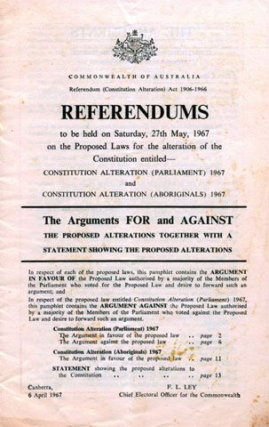

Political Parties
- What is a political party? (2-3 Sentences)
- Name the two major political parties in Australia.
Below is a video that may help you understand more about the history of the Australian Government.
Task 2: Federal Government
- Create a powerpoint presentation about the Federal Government.
You must include:
➡ Structure
➡ Responsibilities
➡The Govenor-General and the British Monarch
➡ Gough Whitlam and the Dismissal
➡ Interesting Facts about Parliment and Government
Below is a video about Gough Whitlam and the Dismissal.
Task 3: State Government
- Design a poster that shows the responsibilities of the state government. This poster must be made using 1x A4 page (on the computer; paint, publisher or word documents can be used). There are 10 different responsibilities that should be shown on your poster. Remember posters are meant to look interesting and catch the eye of any random person walking past.
Task 4: Separation of Posters
- Design a Visual Flow Chart that shows how the Separation of Powers operates in Australias Democracy.

